SOCIETY’S CURRENT AND FUTURE OPINION ON AI AND IF THEY ALIGN WITH EXISTING RESEARCH

  - Empirical Evidence from Survey-Based Research

  - Cyber Security, Bath Spa University
  - 20/10/2025

Abstract
This study investigates the role of artificial intelligence and contemporary technologies in people’s lives through a mixture of literature survey and a two-phased cross-sectional survey conducted in Greece and the United Kingdom. The research consolidates previous observations that AI is productive in various aspects, like increasing efficiency, better healthcare diagnostics, and personalised learning, but what engages is the issue of data quality, project-failure rates, and other ethical concerns, along with the cognitive effects of overdependence on AI tools. The survey of 150 respondents gives an insight into the existence of pronounced generational and cultural differences: the younger ones utilise AI more often, hold a greater amount of trust, and expect a positive impact on society, while the older ones are more doubtful about the privacy, job security, and the overall reliability of the system. Some notes and initial versions were made in Greek, as English is my second language; the use of two languages benefited the accurate interpretation of sources and the clearer academic writing in English. To sum up, the research states that AI is not good or bad by its nature; its effects rely on the quality of data, legal frameworks, digital literacy, and responsible societal incorporation.

Contents
1. Introduction 5
2. Literature Review 6
2.1 Positive Impacts of AI and Technology 6
2.1.1 Efficiency and Productivity 6
2.1.2 Healthcare and Education 6
2.2 Limits, Risks, and the High Failure Rate of AI Adoption 7
3. Cognitive and Psychological Effects 8
3.1 Evidence from Neuroscience 8
3.1.1 Experimental Setup 8
3.1.2 Neural Connectivity Findings 8
3.1.3 Cognitive Debt Indicators 8
3.2 Broader Cognitive Decline and User Behaviour 8
3.2.1 Impact on Sense of Ownership 8
3.2.2 Effects on Memory and Recall 9
3.2.3 Cognitive Offloading Behaviours 9
3.3 Public Perception and Trust in AI 9
3.3.1 Awareness and Expectations 9
3.3.2 Trust in Institutions 9
3.3.3 Gap in Public Understanding 9
3.4 Regulatory Responses (EU AI Act) 10
4. Methodology & Approach 11
Research Question 11
4.1 Data Collection 11
4.2 Data Collection Process 11
4.3 Survey Respondents 12
4.4 Ethical Considerations 12
5. Findings and Discussion 13
5.1 Age-Based Differences 13
5.2 Country Differences 14
5.3 Positive Attitudes Toward AI 14
5.4 Negative Attitudes Toward AI 15
5.5 Second phase – Online quiz 16
5.6 Overall Quiz Analysis 17
6. Conclusion 18
6.1 AI Advantages and Efficiency 18
6.2 Technical and Organisational Challenges 18
6.3 Public Perception and Trust 18
6.4 Regulatory Approaches 18
6.5 Implications and Future Outlook 19
References 20
Appendix 22

1. Introduction
In the past couple of decades, technology has changed human life in a manner that was once considered to be only a fantasy (Singla et al., 2024). With the help of AI and modern technology, the use of smartphones that instantly connect us globally, and algorithms that determine what we watch, listen to, or buy, human beings have made tech an inseparable part of their day-to-day life (Chavda, 2025). This ubiquity of AI in human existence signals the dawn of a genuine digital revolution, a phase wherein the machines not only provide human assistance but also acquire knowledge, modify their behaviour, and even make decisions together with humans. The development of computer hardware, data, and network technologies, one after another, has enormously widened the range of AI's real-world uses.
Nonetheless, as this technological revolution continues, there is an increasing dilemma that society must deal with. The positive side of the coin is that AIs and automations produce great benefits: they can make the processes more efficient, lessening human mistakes, and providing new avenues of creativity and innovation (Singla et al., 2024; McKinsey & Company, 2024). Contemporary technologies and AI have virtues, but at the same time, they bring a whole range of ethical, social, and psychological issues to the surface. Among the most important of these concerns are the automation of labour, the growing dependency on smart machines, and the difficulties connected with data privacy, which all have a direct impact on human life in general. These worries emphasise the need for an investigation into the effects of artificial intelligence and modern technologies on the behaviour of people, social connections, and moral values, thus generating a debate about the question of whether their overall impact on daily life is good or bad.
This research intends to explore the connection of AI with new technologies and human daily life through existing research and public perception comparison. Interrogating both the merits and the demerits of using AI, the study formulates its major query: what is the impact of artificial intelligence and modern technologies on daily life and, at that, whether society considers this impact to be mainly positive or negative.

2. Literature Review
The world of tasks has changed a lot due to the intervention of AI and modern technologies; the efficiency and productivity levels have been raised to new heights, cutting across different areas of work. Human beings and businesses are driven to the more creative, strategic, and high-value activities by the automation of mundane tasks, the screening of big data and the provision of smart insights (Chavda, 2025). Presently, AI is no longer confined to the research room; it operates automobiles, detects medical disorders, controls finance, and creates art.

“AI is the new electricity”
ANDREW NG (Graduate, 2017)

Intelligent homes, gadgets that can be worn on the body, and automatic offices are some of the places that are able to gather and distribute data without any interruptions, and this has a great impact on people's lifestyles as well as their interactions with the world. The various industries are becoming more productive, the health care systems are more accurate, and communication has become easier of all times. Next, we are going to look at the different ways that AI adds to the efficiency and productivity in workplaces, and in human services that are of prime importance, like healthcare and education.

2.1 Positive Impacts of AI and Technology

2.1.1 Efficiency and Productivity
Automated systems, like those utilising predictive analytics and AI, not only reduce the duration of repetitive activities but also increase overall productivity. AI-driven insights are the primary enablers of rapid and precise decision-making in the corporate environment, thus making the entire process more efficient and less vulnerable to errors (McKinsey & Company, 2024).
On top of that, AI impacts significantly the small and medium enterprises (SMEs) sector significantly, with the smart scheduling and inventory management systems cutting waste and increasing productivity.
In the public sector, the application of artificial intelligence is revolutionising the provision of services through better resource allocation, administration task automation, and predictive modelling. One local authority, for instance, uses AI in traffic management, energy demand forecasting, and citizen services facilitation, which leads to achieving financial savings and faster response times simultaneously (Office for National Statistics, 2025).

2.1.2 Healthcare and Education
In the healthcare sector, systems for diagnosis based on machine learning increase the precision of tests and reduce the duration of the testing process (IBM, 2025; UNESCO, 2025). In education, adaptive learning environments are quick to respond to the individual student’s speed, needs, and feedback, and support is personalised, which traditional methods find difficult to match (Chavda, 2025; Brynjolfsson & McAfee, 2014). An illustration of this is the IBM Watson for Oncology, which supports the medical practitioners in the investigation of patient information and the delivery of individualised cancer therapies, thus enhancing the precision of diagnosis and shortening the period of decision-making (IBM, 2025).
AI systems can take over standard administrative jobs, support diagnosis with instant insights, and allow for interactive healthcare experiences that revolve around individual patients. Not only do these technical upgradations relieve the burden of work on the health workers, but they also improve the quality of care and the patient’s journey, and therefore, show the practical advantages of AI in very essential human services. (IBM 2025)

2.2 Limits, Risks, and the High Failure Rate of AI Adoption
The implementation of AI might be a topic with two sides, one of which is the very complicated reality of AI. An MIT/industry analysis has recently stated that nearly 95% of AI projects yield no visible value (Drenik, 2025). However, the reason for the failure is not the AI models but the poor quality of organisational data. Most enterprise data is not "AI-ready": it is incomplete, outdated, inconsistent, or unrepresentative. Consequently, the systems that are derived from such datasets are either unreliable or biased.
On the flip side, the reliance on AI systems for cognitive tasks can pose neurological risks as per the latest research. The study conducted by MIT (Kosmyna et al., 2025) revealed that the constant use of Large Language Models for writing tasks resulted in the thinning out of neural engagement reflected in the connectivity. Those involved in the research and who were always dependent on AI were in difficulty when it came to remembering the content that they had just produced, and they felt that their claim to the authorship of the work was very weak (Science, Public Health Policy and the Law, 2025). What is more, even after the AI use was stopped, the cognitive performance of these individuals did not completely go back to the original level, which is a sign of "cognitive debt" and a long-term adaptation of the individual to a passive role.

3. Cognitive and Psychological Effects
Writing and decision-making are some of the activities where AI applications have been heavily relied upon, and their consequent negative feedback on neural engagement, memory recall, and the like have been termed “cognitive debt” (Kosmyna et al., 2025; Science, Public Health Policy and the Law, 2025).

3.1 Evidence from Neuroscience

3.1.1 Experimental Setup
The long-term impact of employing LLMs on writing related brain activity has been a topic of recent experimental research from MIT (Kosmyna et al., 2025), which involved monitoring 3 different groups of people: those who were using the LLM, those who were using a search engine, and a “brain-only” group writing without any external support. Participants in each group underwent several writing sessions during which their neural activity was continuously monitored through EEG.
Notably, AI-supported writing tools in education have been found to improve the quantity and quality of text produced when used as a system of support (Clark & Gruba, 2010). Moreover, the theory of cognitive load advocates that tools which lessen the processing of irrelevant information can lead to a greater cognitive engagement with the learning material (Sweller, Ayres & Kalyuga, 2011).

3.1.2 Neural Connectivity Findings
The outcome was that cognitive engagement varied a lot among the groups. Participants using only the brain showed the strongest and most distributed neural connectivity, while search engine users experienced moderate engagement. On the other hand, the LLM users showed the weakest connectivity.

3.1.3 Cognitive Debt Indicators
In addition, when LLM users attempted to write without AI assistance in later sessions, they demonstrated the loss of memory recall and lower activation in prefrontal. This research points to the idea of “cognitive debt,” which means that the use of AI tools leads to an eventual long-term shift towards inactivity and reduced engagement, even when the tools are no longer available. The present research illustrates the necessity of considering the neurological repercussions of AI dependency on learning, attention, and memory over time.

3.2 Broader Cognitive Decline and User Behaviour

3.2.1 Impact on Sense of Ownership
The same MIT study's follow-up analysis methodically examined the behavioural effects of AI heavy usage (Kosmyna et al., 2025). The users of LLMs in writing tasks reported an absence of feeling tied to their work, when they claimed that only a small part of the text was their own. Conversely, the brain-only participants steadily stated total ownership and even more being involved.

3.2.2 Effects on Memory and Recall
Ordinary LLM users in everyday scenarios could not very easily remember or cite the texts they had just composed, however, users relying solely on search engines and their brains demonstrated significantly better memory recall.

3.2.3 Cognitive Offloading Behaviours
The investigation reveals a cognitive offloading process, where the human mind gradually disconnects from active synthesis, memory retention, and creative effort and relies on the AI system to perform these tasks. This behaviour may lead to a temporary increase in efficiency, but it also brings the danger of dependency in the long run and lowering of cognitive resilience.

3.3 Public Perception and Trust in AI
Previous studies have identified similar trends. The research from the Pew Research Center (2023) shows a striking difference in the degree of optimism between young and old adults with respect to AI's societal impact (Pew Research Center, 2023). Similarly, the Eurobarometer (2023) indicates that the more digitally skilled Europeans are, the more they trust AI systems (European Commission, 2023). These findings are consistent with the PADAI survey results, confirming the existence of a gap in AI perception influenced by age and knowledge factors (GOV.UK, 2024).

3.3.1 Awareness and Expectations
Not only are there cognitive and behavioural effects, but also the widespread acceptance of AI and society is eventually determined by public perception and trust. The Public Attitudes to Data and AI (PADAI) Tracker Survey, conducted by the UK Responsible Technology Adoption Unit (GOV.UK, 2024), reveals that most adults are now aware of AI and yet still have mixed perceptions about it. The number of adults who expect positive effects of AI on society, especially in the fields of healthcare, climate monitoring, and public services, is about 40%, while the negative impacts predicted by 30% of adults cover issues like misinformation and job loss.

3.3.2 Trust in Institutions
According to the PADAI survey (GOV.UK, 2024), there is the opinion of 65% of respondents believe that AI would be handled by universities and the NHS in a responsible way, but only 20% think the same of social media companies and 25% of state governments. This creates a colossal gap of trust between them. Moreover, the Pew Research Center (2023) mentions that older people and those with limited computer skills are usually the ones who hesitate to adopt AI technology, which indicates that trust in technology is a major controlling factor for the acceptance of AI. The NHS and university researchers are the ones trusted most in any situation, but on the other hand, social media companies and the government are the least trusted. People who are not up to date with the digital world or who are older usually have more concerns when it comes to data security, privacy, and accountability, which indicates that the more confident one is in the use of a particular technology, the more positive the attitude toward AI will be.

3.3.3 Gap in Public Understanding
Moreover, the survey indicates that there is a big lack of information among the participants regarding the way AI systems are trained: about 70% of them claim that they are almost completely ignorant of this process (GOV.UK, 2024). The situation where there is no understanding, together with different opinions and trust levels, highlights even more the need for making the AI deployment process very transparent, for being very ethical in designing AI, and for bringing the public into the discussion (European Commission, 2025). The implications of these findings are in line with the ongoing conversations on AI governance and regulation in general, such as the case of the European Union’s AI Act, which strives to do so by facilitating the coexistence of innovative and safe, accountable products.

3.4 Regulatory Responses (EU AI Act)
Considering the potential risks, the EU brought forth the AI Act, the first-of-its-kind global, comprehensive artificial intelligence legal framework (European Parliament, 2025). The Act categorises AI systems by the risk they present, from very low to high risk, and prohibits some applications as unacceptable, such as social scoring and real-time facial recognition in public areas. High-risk systems, including but not limited to those employed in critical infrastructure, healthcare, and education, are subject to rigorous assessment, monitoring, and transparency obligations. Even generative AI tools, such as ChatGPT, are required to identify AI-generated content and prevent illegal outputs. Such a regulatory framework demonstrates the increased awareness of society that, although AI can improve efficiency, productivity, and innovation, it still needs governance to protect fundamental rights, to ensure accountability, and maintain human oversight.

4. Methodology & Approach
A cross-sectional survey was performed to examine how the public perceives and what impact they foresee AI having on their daily lives and society. The survey was done in two different countries with participants aged 15–60. The main goal was to gather quantitative as well as qualitative data on people's attitudes, usage, and trust towards AI technologies, which would lead to answering the research question:

Research Question
"What is the influence of artificial intelligence and modern technologies on our daily lives, and how do people view this influence for the future?"

4.1 Data Collection
Data came from an online quiz that had eight main questions:
- Age: It was possible to separate the answers according to age and to look for patterns and trends in different age categories.
- How often is AI used in the daily routine to check the level of exposure and the degree of acquaintance with AI technology?
- What AI types were used – the respondents could tick several options, including chatbots, recommendation systems, virtual assistants, or any other AI tools.
- AI's influence on daily life - the respondents were asked if they considered AI to be a factor in making life hassle-free.
- Evaluation of the job risk scenario – the respondents gave their opinion on whether AI and automation would leave humans without jobs.
- Personal data treatment by AI - gauging the level of trust in the AI’s reliability and the data privacy policy.
- Judgement about societal progress - the survey participants were asked if they thought that AI had an overall positive contribution to society.
- Feeling about the future of AI - the survey participants were asked to give their overall feeling about the long-term impact of AI.

4.2 Data Collection Process
Public opinion regarding Artificial Intelligence (AI) was subjected to a multi-faceted approach through two-stage research, which brought together both the depth and the range of understanding.
In the first stage, a small but focused sample of 50 individuals was employed for one-on-one surveys. The participants came from two different countries, Greece and the UK, and could directly compare the feelings and opinions of people from other cultures. The individual surveys contained the eight key questions already mentioned, covering issues like AI application, trust, expected impact on society, and expectations on AI's future. This phase was aimed at producing comprehensive, age-distributed samples, making it possible to discover the patterns and trends according to age groups. This first stage, while emphasising the importance of subtleties in individual opinions, also pointed out that the divergence between the younger and older participants was significant.
In the second stage, the survey was converted into an online quiz format and disseminated to about 100 people, which is the size of the target group. This method allowed for the collection of quantitative data that was on a larger scale, and the data was subjected to the analysis of general trends and patterns. The study ensured that the larger survey could be interpreted meaningfully by the application of the insights gained from the smaller sample, using the individual replies as a reference point to validate wider conclusions.
The two-phase approach in research - initially selecting a small, specific group, and subsequently enlarging it to a larger crowd - not only demonstrates that the qualitative aspect has been thoroughly probed but also that the quantitative aspect is of significant statistical validity. The investigation, with such a wide variety of methods, can not only uncover the usage and perception of AI but also the variation in these perceptions among different ages, countries, and levels of digital familiarity.

4.3 Survey Respondents
A hybrid-method approach was used to select the survey participants. The respondents, who were friends and family, voluntarily agreed to be a small part of the total. Additionally, people who did not know me were asked in public places like streets and meeting points to give their opinions and their answers were noted down. For the online quiz, I asked my friends and family to send it to as many people as they could, so I could gather the desired result of the answers I had set as a target from the online quiz, which was around100 people. This mix of methods not only produced a varied sample but also reduced the risk of all the answers coming only from my direct social circle. I used the same technique for both Greece and the UK for my data collection process.

4.4 Ethical Considerations
It was communicated to all participants that their participation in the survey was not mandatory and that they could refuse to provide answers to any questions. The confidentiality of the participants was guaranteed, as there was no collection of names or any other identifying information. The responses were recorded and securely stored, used solely for this study, and processed in compliance with ethical research practices. Despite the data presented in this report, the identity of no participant can be determined. During the collection of the data, I was using numbers as IDs for each participant.

5. Findings and Discussion

5.1 Age-Based Differences
The different age groups showed obvious differences because of the analysis of a total of 150 responses. The younger ones (15–30) were very much more familiar with AI technologies, not only using them more but also trusting the AI more. The overall attitudes of the younger group were very optimistic since a majority believed that AI would enhance convenience, productivity, and even the technological development of the future.
On the other hand, the older group, especially those over 45 years, was more sceptical. Through their responses, they showed that they had very low levels of trust, especially when it came to handling of personal data, and that they were much more concerned than the others about human jobs being replaced by machines. They also voiced their doubts or even disapproval about the impact of AI on society in the long run. These trends indicate that those who have experienced both modern and old-fashioned lifestyles evaluate AI more sceptically.

Figure 1: Ages and opinions.

The figure vividly portrays the variations in the perception of AI over different age groups according to the information in section 5. People in the age bracket of 15–30 years are the ones with the most pronounced positive viewpoint, the number of them being overwhelmingly greater than the sum of all other sentiment categories. The 30–40-year-olds seem to be the most concerned, with a mix of being somewhat optimistic and neutral. On the other hand, the older generation (40+ years) is very biased against AI, having less hope than the youth. In conclusion, the illustration points at the generational divide, since the younger group is more comfortable with technology, while the older ones are still concerned and doubtful to a certain degree.

5.2 Country Differences
The differences in the responses of Greece and the UK highlighted the cultural and infrastructural differences more greatly. The UK participants were overall more confident and more open to AI integration, indicating that they were accustomed to more developed digital ecosystems and everyday technological services.
Contrarily, Greek participants, especially older age groups, exhibited more fear, uncertainty, and distrust. One possible reason is that the UK has more technology in daily life; therefore, the rapid AI developments are felt less strange or threatening. The difference between the two countries was clearly shown in concerns over job security and data privacy, with Greek respondents always voicing their worries more strongly.

Figure 2: The differences between countries in the trust of AI.

5.3 Positive Attitudes Toward AI
A group of respondents displaying almost exclusively positive attitudes had several common characteristics. This group was usually younger, more frequent users of AI tools, and had a good perception of the advantages that AI could provide about convenience, automation and the support of daily tasks. They were also more likely to think that AI was a good thing for society and had a positive view of its future. The degree of trust they had in AI varied importantly, but it was moderate to high if we look at non-sensitive applications like productive tools, recommendation systems and virtual assistants.
The positivity of the younger ones among the respondents indicates the trend of the global surveys, where the digital-native groups feel AI is nothing but a continuation of the current tech rather than a disruptive force. The use of recommendation systems, adaptive learning tools, and automation by these digital natives lowers the unpredictability factor that older people experience. 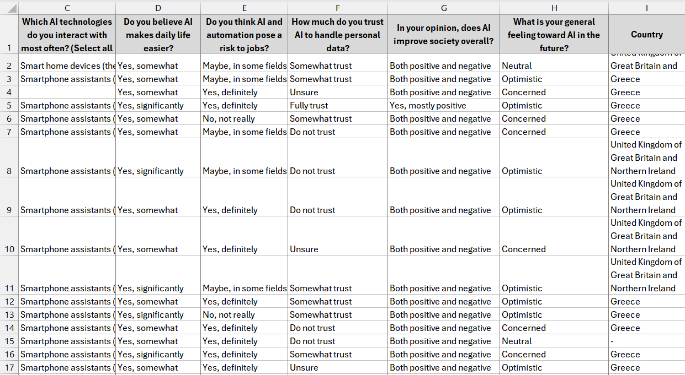
Figure 3: Ages 15-40
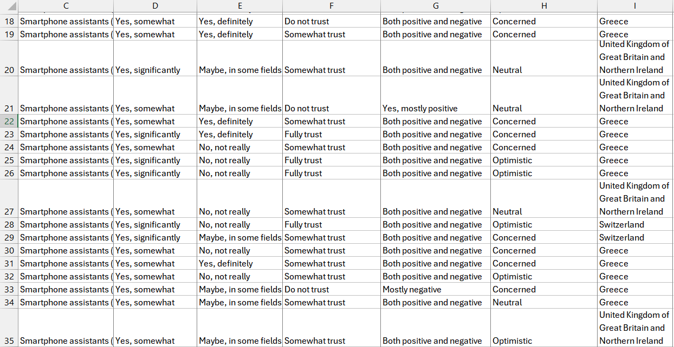
Figure : Ages 15-40

5.4 Negative Attitudes Toward AI
Participants with negative or worried opinions made up a separate group that was most often found in the older age categories. According to this group, AI systems' reliability was a matter of doubt, and the ability to securely store personal data was questioned, while automation was seen as a direct threat to human labour. Many people believed the negative impact of AI on society would be the most pronounced in the areas of privacy, ethical risks, and workforce disruption.
The responses from this group also point to the fact that a lack of knowledge about technology leads to more distrust. In Greece, especially, the older participants were more frightened of AI than those in the UK, which supported the assumption that the level of technological exposure is the determining factor for the public's perception of being pro or anti-tech.
The negative attitudes of older participants appear to be shaped by the weighing of risk awareness that they did and by not accepting technological uncertainty at a high level. Quite a lot of participants expressed their concerns about AI taking control over humans, and the monitoring increased, and even the dissemination of falsehoods in public places might be accelerated. The cautious position they took was like the principle of 'safety first' that is deeply rooted in the legal regulations, for instance, the EU AI Act.
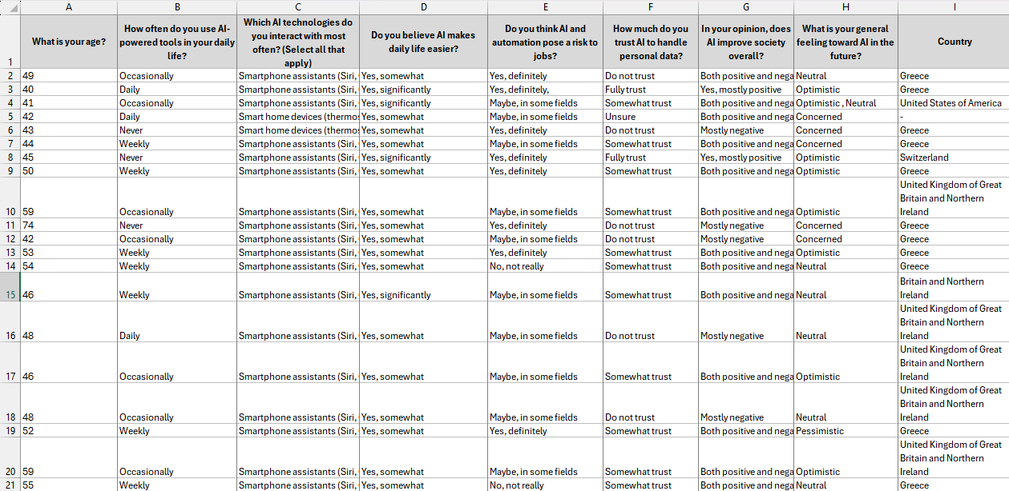
Figure 5: Ages 40+

5.5 Second phase – Online quiz
For the second phase of the research, an online quiz was taken by around 100 participants whose ages varied between 15 and 60; however, most were more than 20 years old. The findings primarily corroborated the trends that were already noticed in the smaller first sample. Whereas younger ones kept on displaying positivity and faith in AI technologies, most of the older ones and the middle-aged ones at least were very much sceptical about the future of AI and were particularly concerned about the areas of job security, privacy, and ethics. A tiny group of participants, though, trusted the controlled and governed innovation of AI, thus portraying cautious optimism. The comparisons of these results with those of the initial 50-person survey revealed the same broad trends, indicating that age, digital ratio, and tech familiarity are the strongest factors influencing people's perceptions of AI and the public opinion is always divided between optimism and fear.
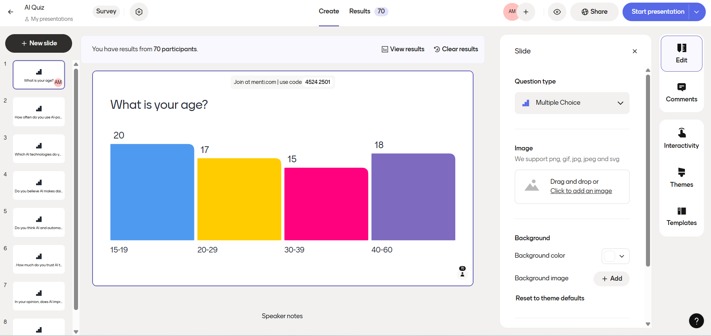
Figure 5: Online quiz

5.6 Overall Quiz Analysis
The quiz results indicate a major difference in the public opinion about AI. The younger group (15-30) constantly manifested their optimism by saying that they used AI tools very often, trusted them and had the same positive expectations in relation to productivity, convenience and social progress. The older people (40+), on the other hand, were very careful and somewhat sceptical, displaying their fears about data privacy, job takeovers, and unreliability of AI systems. Besides, the national differences were also apparent, as UK participants overall were more accepting of AI incorporation than their Greek counterparts, which was probably due to the difference in their exposure to digital environments. To sum up, the quiz points out that the level of intimacy and the degree of trust are the two major factors that determine the stance taken towards AI, while digital literacy is the main factor that can either create optimism or scepticism.

6. Conclusion

6.1 AI Advantages and Efficiency
The research indicates that AI is a cutting-edge technology that can change the entire scenario by bringing in new advantages and, at the same time, posing enormous risks. The Literature Review presented in section 2 mentions that AI is very much able to improve efficiency and productivity, especially in places like workplaces and small to medium companies, through automating the routine, boring work and making decisions that are quicker and more accurate (section 2.1.1). Where human services like healthcare and education are the most important, and AI has taken a role, it facilitates personalised patient care and adaptive learning, giving a glimpse into the daily life benefits of AI being integrated.
6.2 Technical and Organisational Challenges
On the other hand, unusually pointed out in section 2.2 points out that poor data quality and other technical-related challenges lead to the disappearance of numerous Artificial Intelligence projects and underline the necessity for strong organisational practices that can help in producing reliable output.
In the same way, section 3 highlights the brain and the behavioural problems that come with the dependency on AI, including cognitive offloading, memory loss, and the feeling of not being the owner of one's own work (sections 3.1 – 3.2). The results obtained from these studies make it clear that human adaptation to AI technology should be one of the factors considered when the latter is being employed in the long run.

6.3 Public Perception and Trust
The analysis of public perception, described in section 3.4, reveals a divide between generations and countries. The younger ones, who are often digital natives, believe in AI and its contribution to society more than the older people, who share doubts and concerns over privacy, ethics, and job security (5.1, 5.2). Such a digital literacy and technological exposure gap clearly highlights the role of these factors in shaping trust and acceptance.
6.4 Regulatory Approaches
The regulatory approaches done in the main, such as the EU AI Act that is mentioned in section 3.3, are pivotal in fighting the ethical, privacy, and social implications. By performing a risk-based categorisation of AI applications and enforcing transparency, supervision, and accountability, governance lets AI evolve in a responsible manner without compromising on the protection of human rights.

6.5 Implications and Future Outlook
To sum up, the nature of artificial intelligence is not black or white; rather, its influence is the result of prudent design, responsible implementation, proper governance, and people’s willingness to accept it. When backed up with moral support and popular comprehension, AI has the power to push human empowerment and community welfare forward (sections 3 & 5). On the other hand, if no proper measures are taken, the technology will be able to make the situation worse in terms of unequal distribution of resources, less mental participation, and intrusion into privacy.
+-“The development of full artificial intelligence could spell the end of the human race.”
Stephen Hawking

In short, the study asserts that the coming of AI as a digital revolution is based on a combination of human choices, governance, and technological progress.

References
Chavda, J. (2025). How People Around the World View AI. [online] Pew Research Center. Available at: https://www.pewresearch.org/global/2025/10/15/how-people-around-the-world-view-ai/.
Drenik, G. (2025). Why 95% Of AI Projects Fail And How Better Data Can Change That. Forbes. [online] 15 Oct. Available at: https://www.forbes.com/sites/garydrenik/2025/10/15/why-95-of-ai-projects-fail-and-how-better-data-can-change-that/.
European Commission (2025). Eurobarometer. [online] Europa.eu. Available at: https://europa.eu/eurobarometer/surveys/detail/3222.
European Parliament (2025). EU AI Act: First Regulation on Artificial Intelligence. [online] European Parliament. Available at: https://www.europarl.europa.eu/topics/en/article/20230601STO93804/eu-ai-act-first-regulation-on-artificial-intelligence.
GOV.UK (2024). Public attitudes to data and AI: Tracker survey (Wave 4) report. [online] GOV.UK. Available at: https://www.gov.uk/government/publications/public-attitudes-to-data-and-ai-tracker-survey-wave-4/public-attitudes-to-data-and-ai-tracker-survey-wave-4-report.
Graduate, S. (2017). Andrew Ng: Artificial Intelligence is the New Electricity. YouTube. Available at: https://www.youtube.com/watch?v=21EiKfQYZXc.
www.ibm.com. (n.d.). Healthcare Industry Solutions & Services. [online] Available at: https://www.ibm.com/uk-en/industries/healthcare.
Kosmyna, N., Hauptmann, E., Yuan, Y.T., Situ, J., Liao, X.-H., Beresnitzky, A.V., Braunstein, I. and Maes, P. (2025). Your Brain on ChatGPT: Accumulation of Cognitive Debt when Using an AI Assistant for Essay Writing Task. [online] arXiv.org. Available at: https://arxiv.org/abs/2506.08872.
Luckin, R. and Holmes, W. (2016). Intelligence Unleashed: an Argument for AI in Education. [online] discovery.ucl.ac.uk. Available at: https://discovery.ucl.ac.uk/id/eprint/1475756/.
Rabah, T. and Mukhallafi, A. (2014). COMPUTER ASSISTED LANGUAGE LEARNING FOR LEARNING ENGLISH IN SAUDI ARABIA. [online] Available at: https://opus.lib.uts.edu.au/bitstream/10453/29236/9/02whole.pdf [Accessed 5 Jan. 2026].
Roff, B. and Cameron, D. (2025). What the UK thinks about AI. [online] Ipsos. Available at: https://www.ipsos.com/en-uk/what-uk-thinks-about-ai.
Science, Public Health Policy and the Law. (2025). MIT Study Finds Artificial Intelligence Use Reprograms the Brain, Leading to Cognitive Decline - Science, Public Health Policy and the Law. [online] Available at: https://publichealthpolicyjournal.com/mit-study-finds-artificial-intelligence-use-reprograms-the-brain-leading-to-cognitive-decline/.
Singla, A., Sukharevsky, A., Yee, L. and Chui, M. (2024). The state of AI in early 2024: Gen AI adoption spikes and starts to generate value. [online] McKinsey & Company. Available at: https://www.mckinsey.com/capabilities/quantumblack/our-insights/the-state-of-ai-2024.
Sweller, J. (2011). Cognitive Load Theory. Psychology of Learning and Motivation, [online] 55, pp.37–76. doi: https://doi.org/10.1016/B978-0-12-387691-1.X0001-4.
UNESCO (2025). AI and education: guidance for policy-makers. [online] Unesco.org. Available at: https://www.unesco.org/en/articles/ai-and-education-guidance-policy-makers.

‌

Appendix

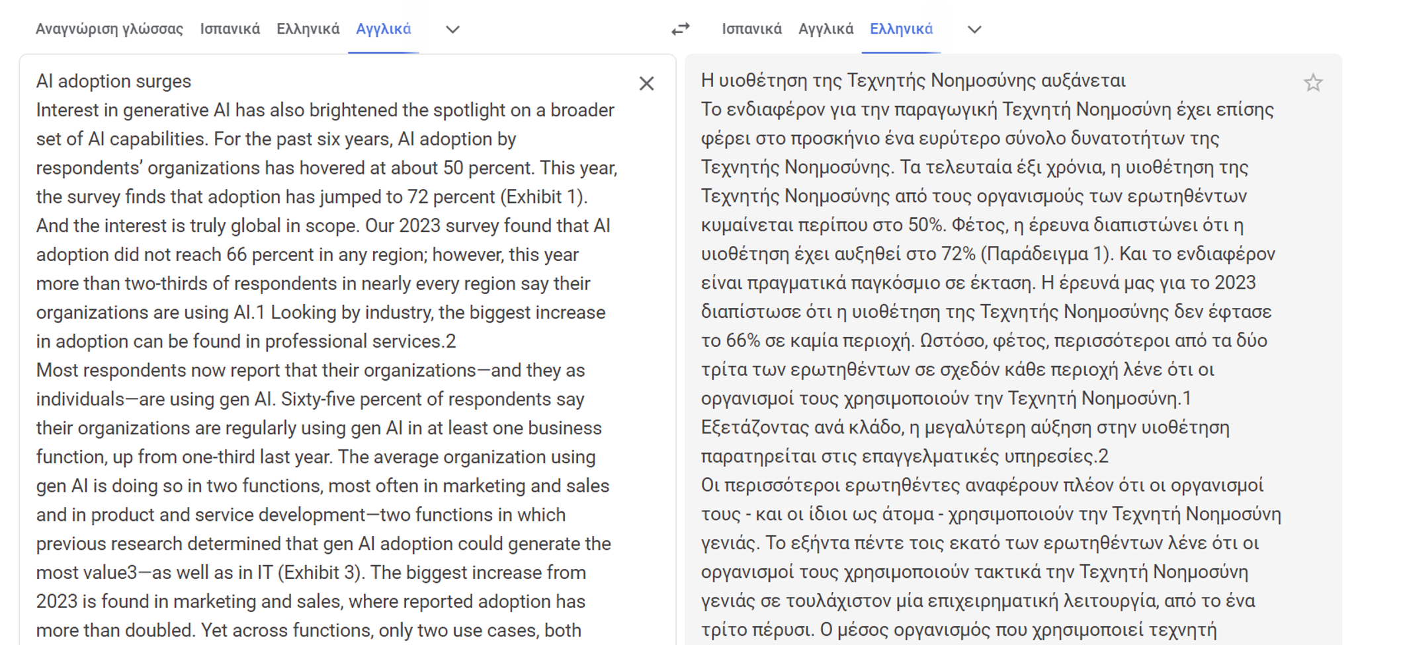
Figure 6: Greek to English translation

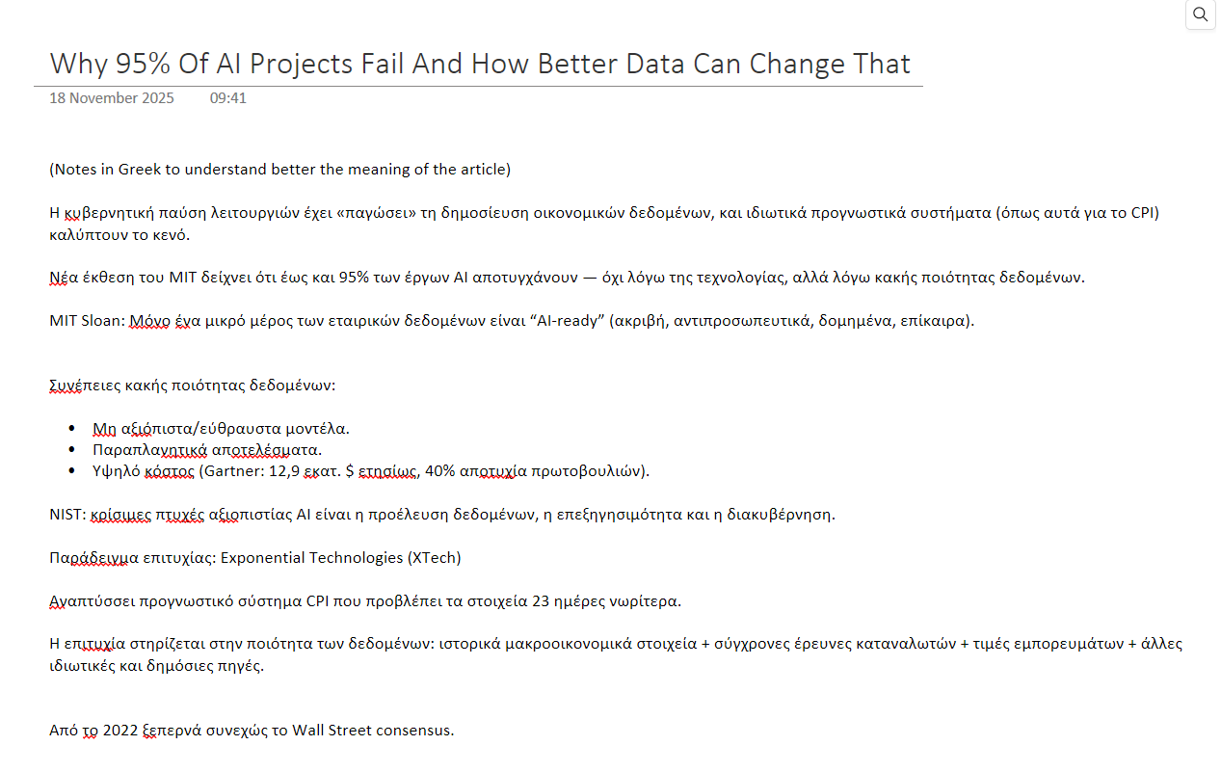
Figure 7: Greek notes of research.
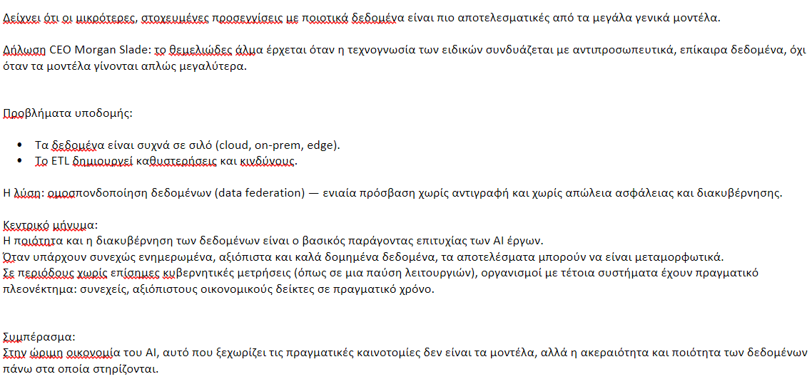
Figure 8: Greek notes of research.
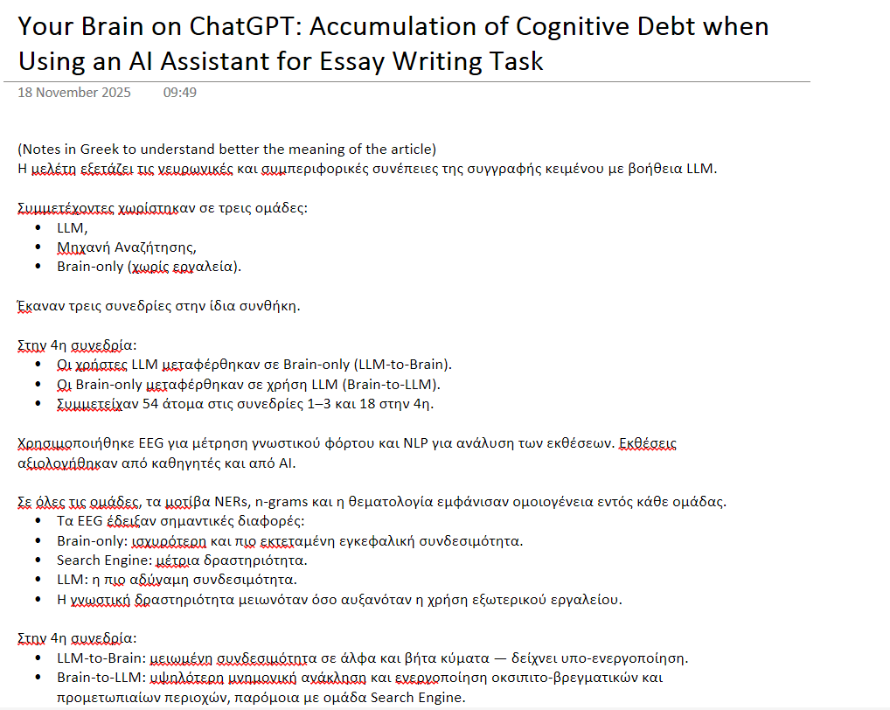
Figure 9: Greek notes of research.
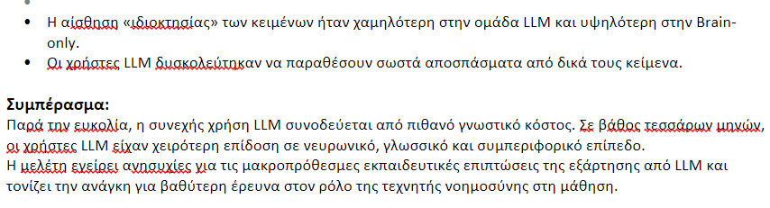
Figure 10: Greek notes of research.
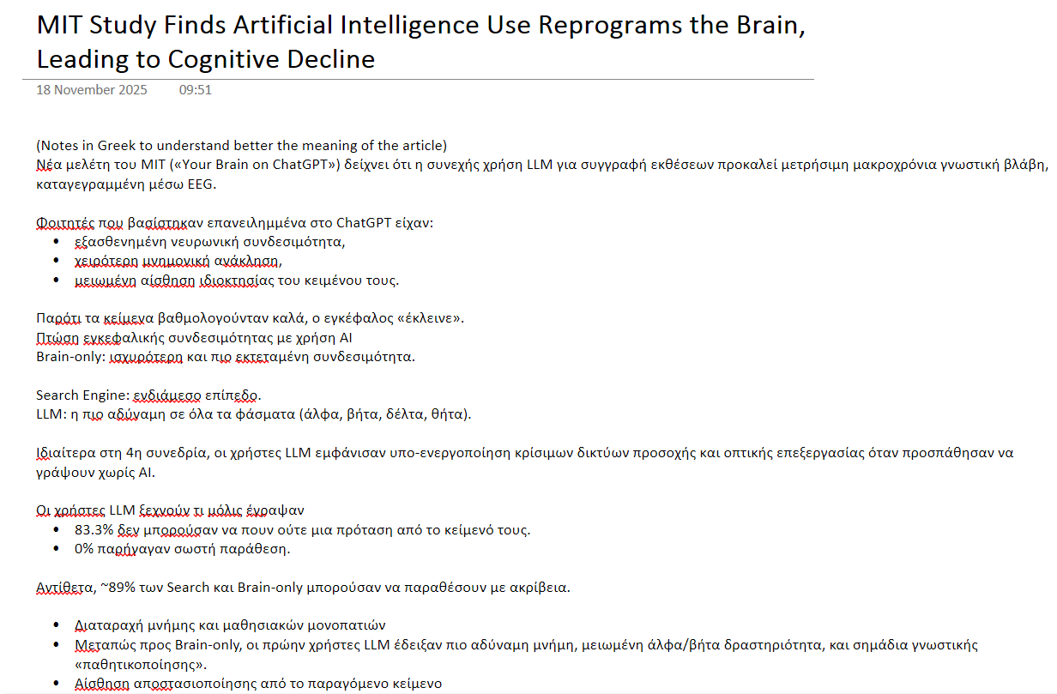
Figure 11: Greek notes of research.
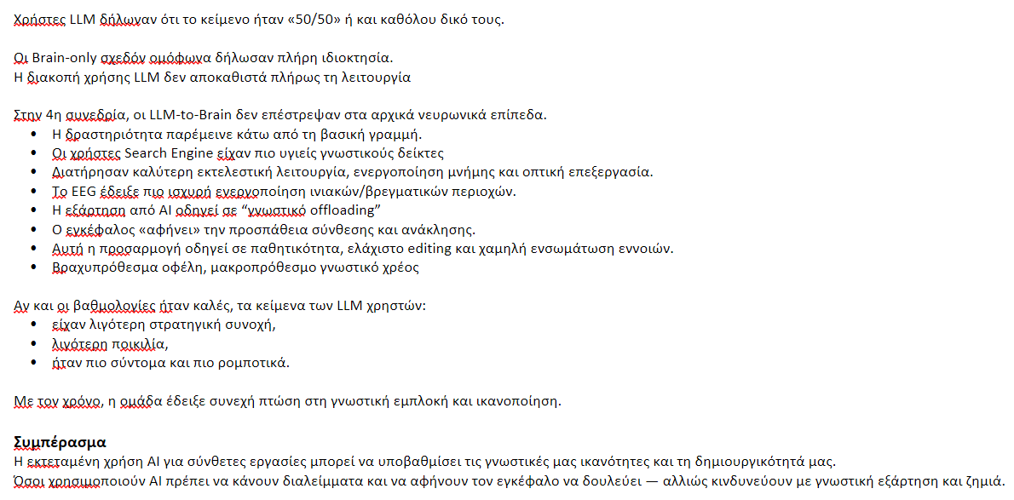
Figure 12: Greek notes of research.
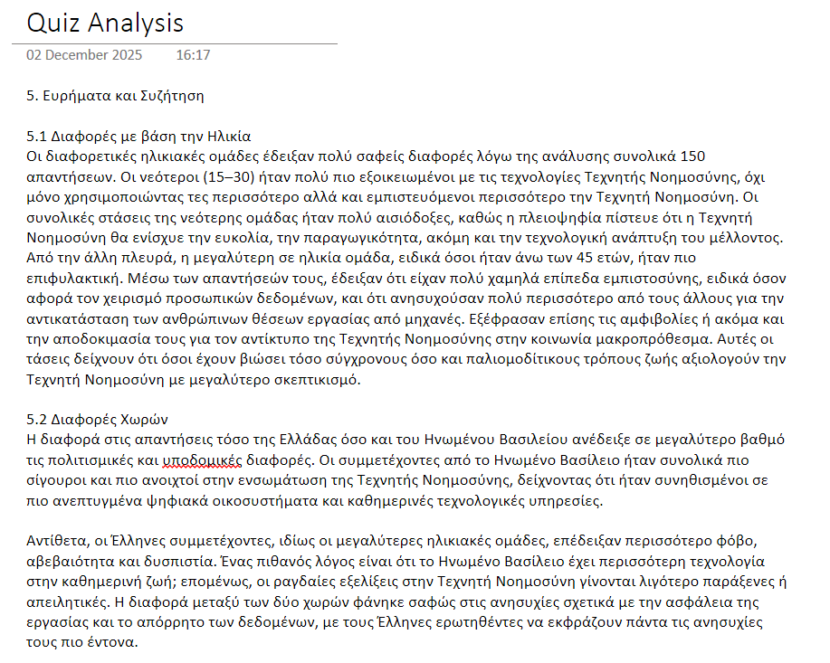
Figure 13: Paragraph 5 in Greek first as a draft.
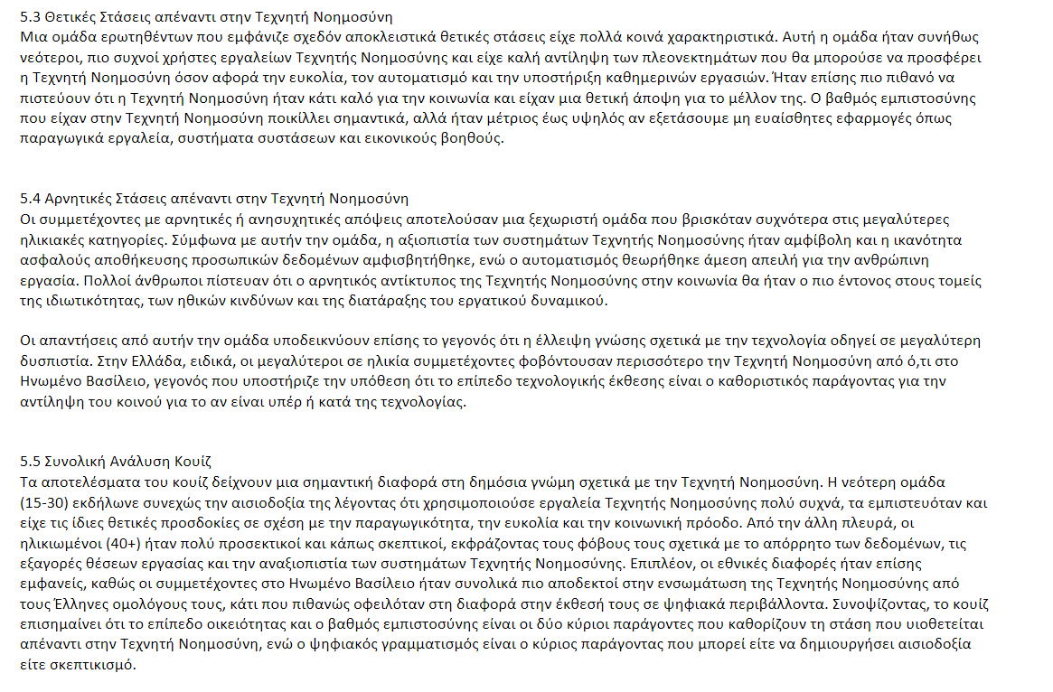
Figure 14: Paragraph 5 in Greek first as a draft.

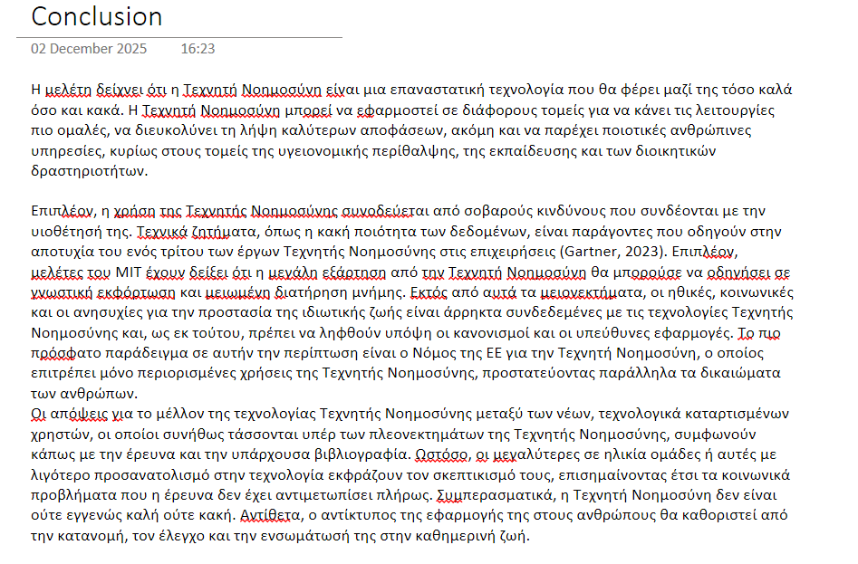
Figure 15: Conclusion in Greek first as a draft.
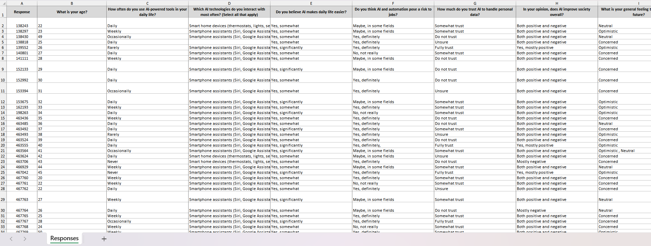
Figure 16: The Excel sheet from the 50 individual answers.
‌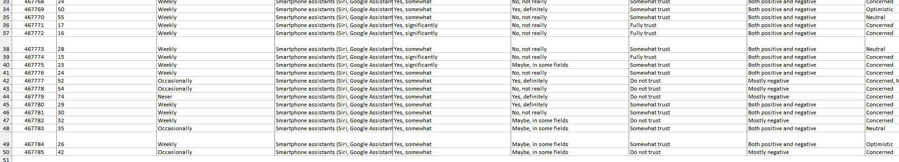
Figure 17: The Excel sheet from the 50 individual answers.

‌
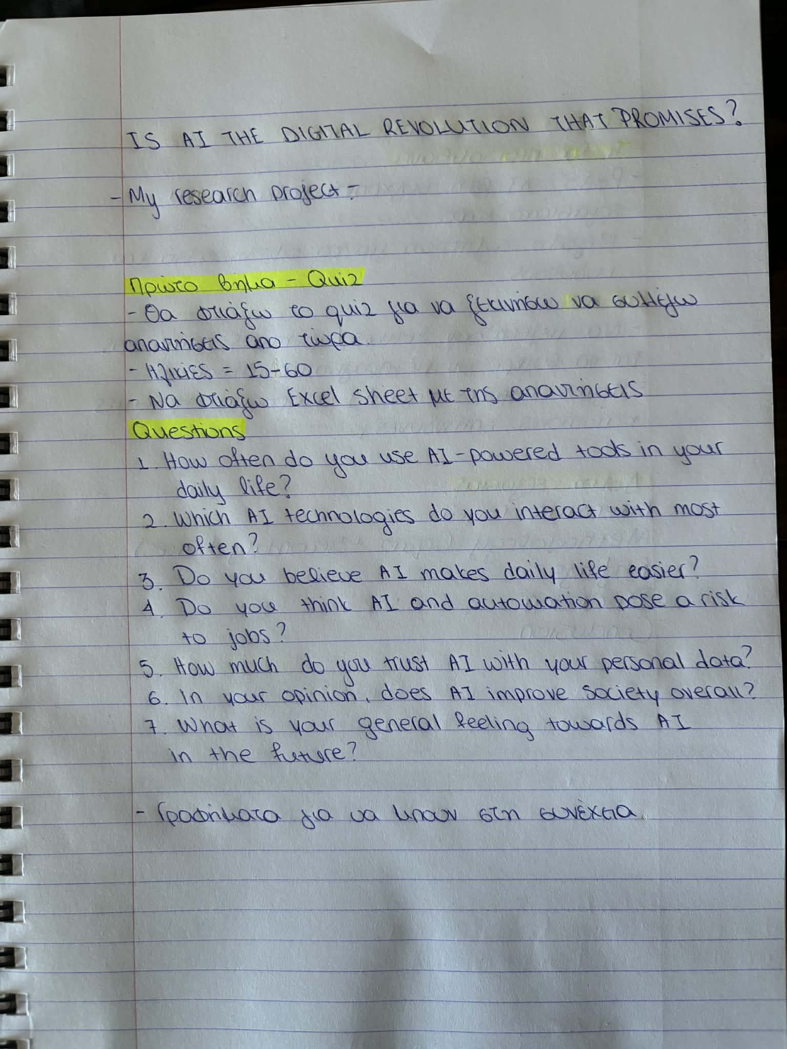
Figure 18: Notes in English - Greek.
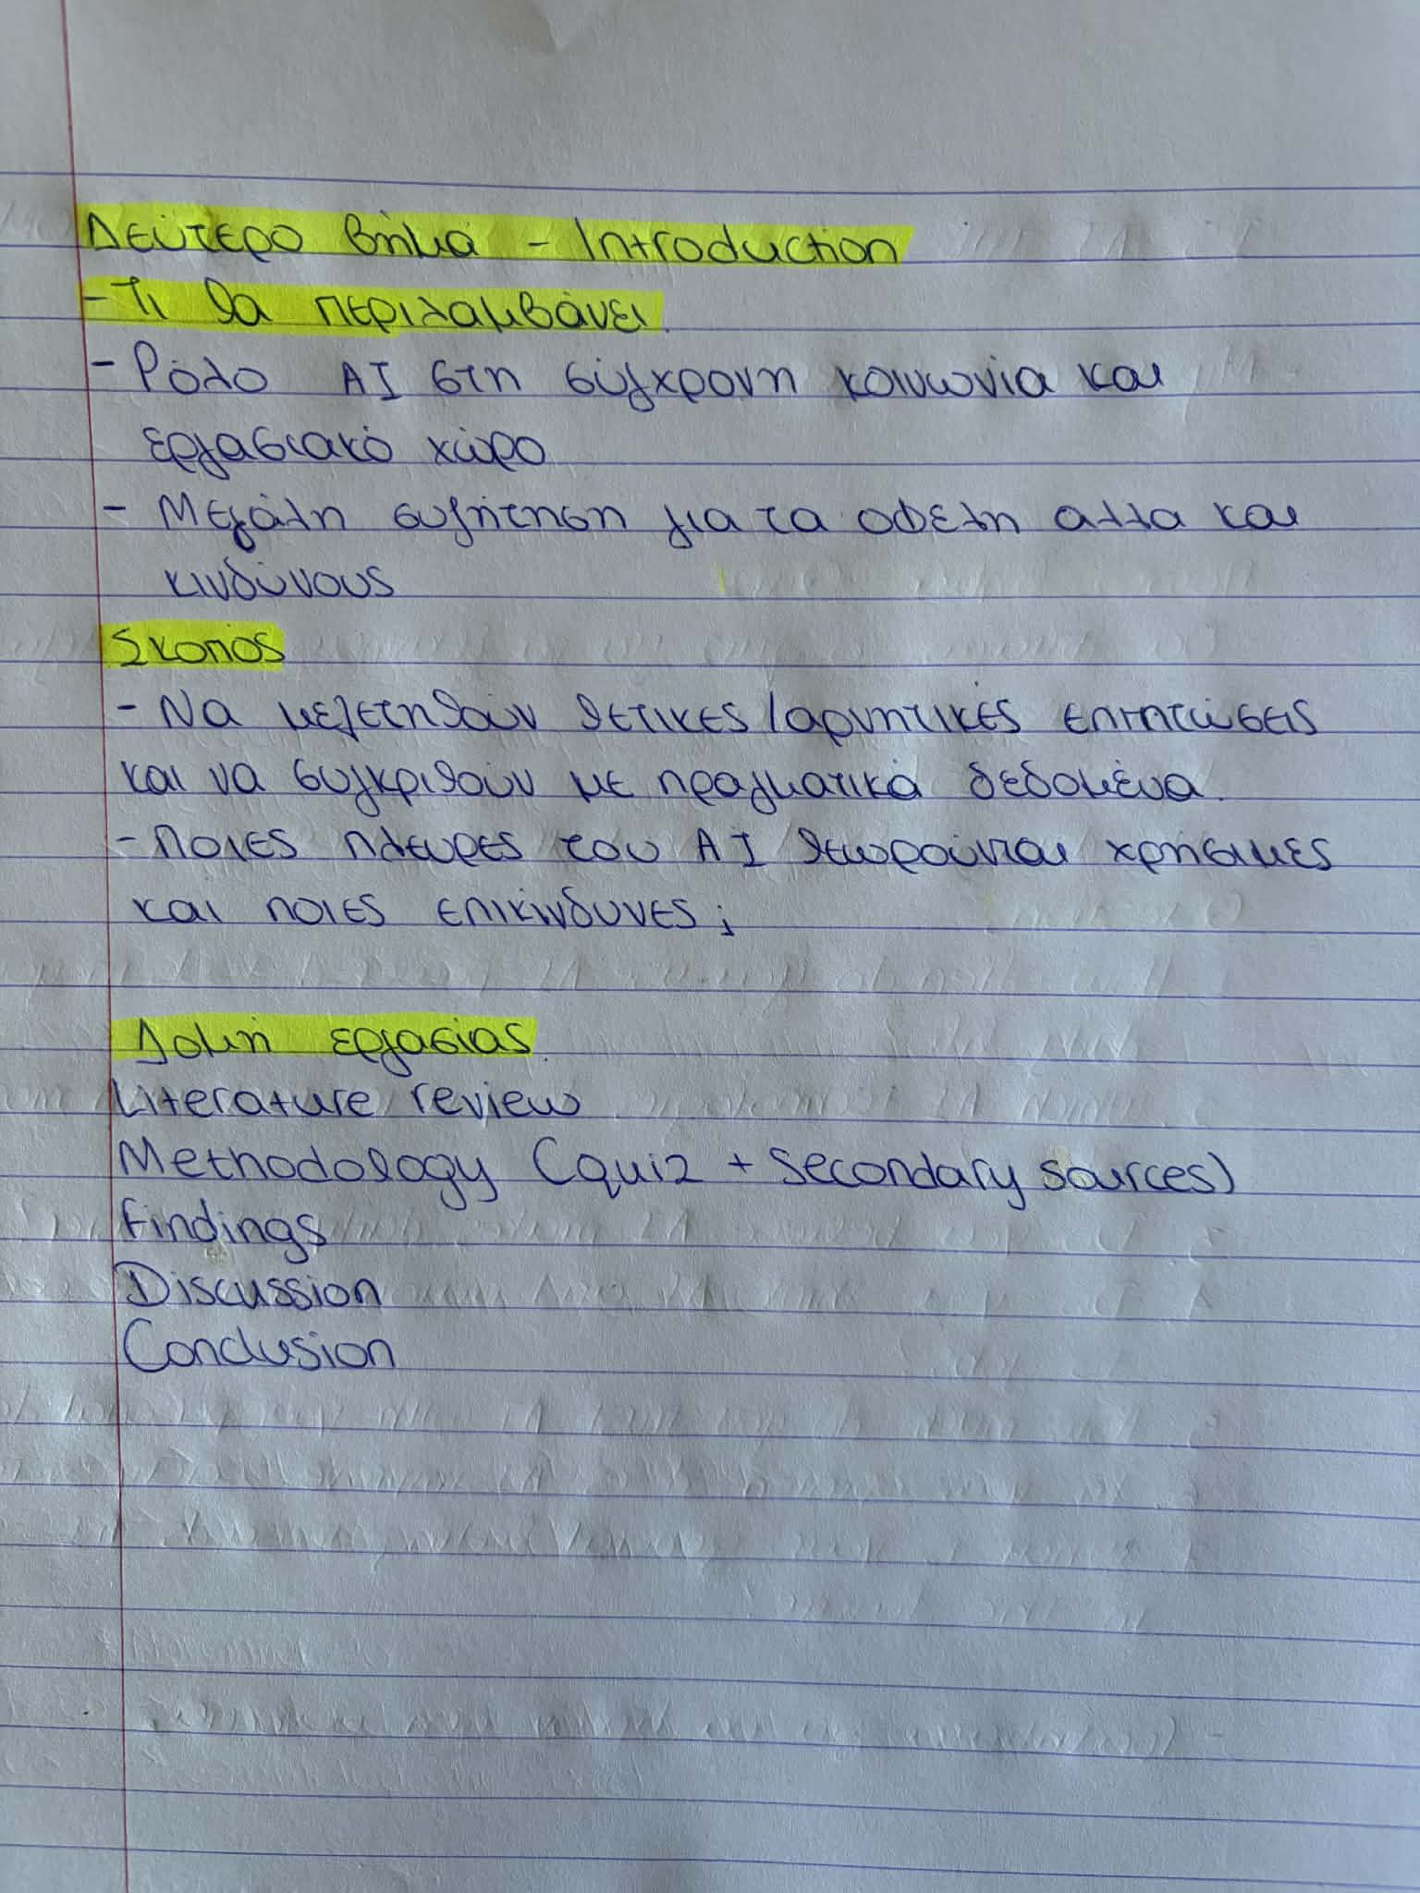
Figure 19: Notes in English - Greek.

Figure 20: Notes in English - Greek.

Figure 21: Timestamp

Figure 22: Timestamp

Figure 23: Timestamp
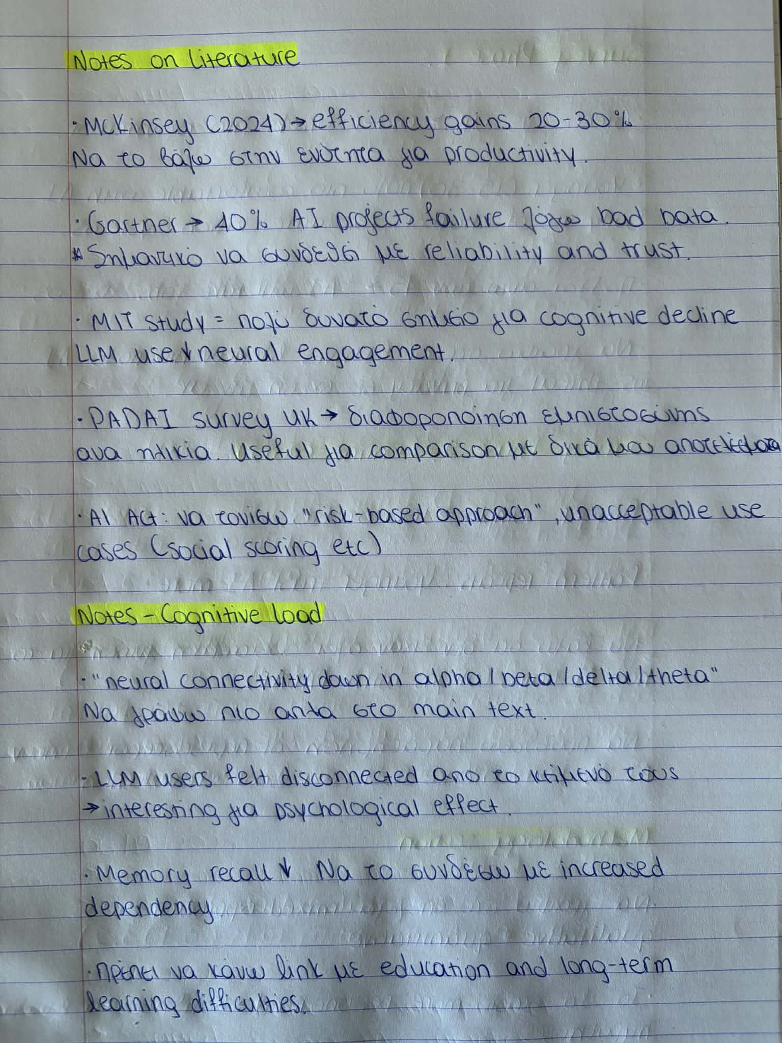
Figure 24: Notes in English - Greek.

Figure 25: Notes for survey phases.
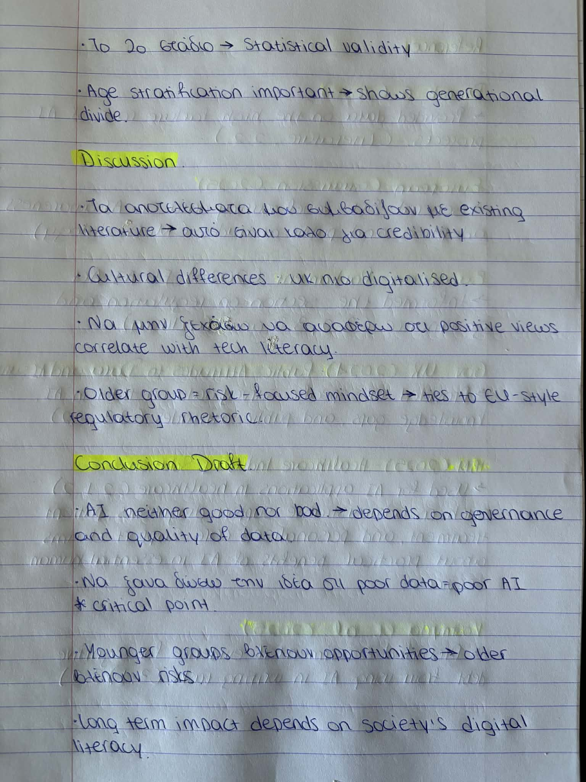
Figure 26: Notes for survey phases.

Figure 27: Reference notes
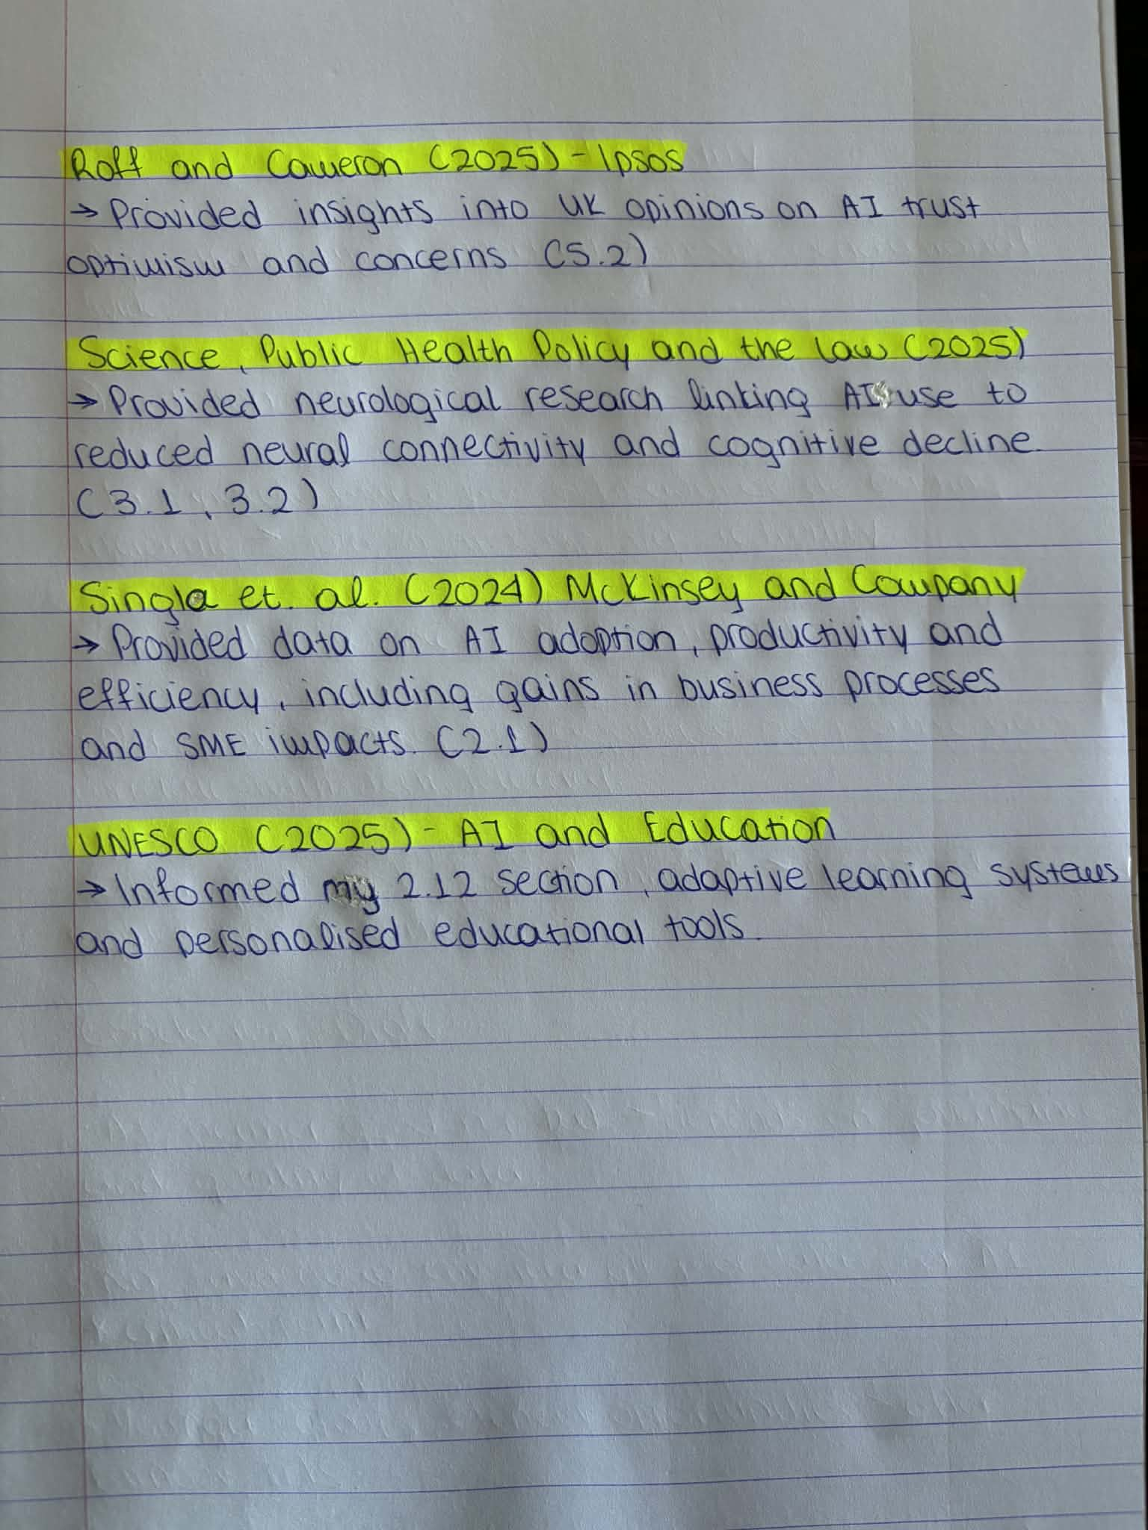
Figure 28: Reference notes
‌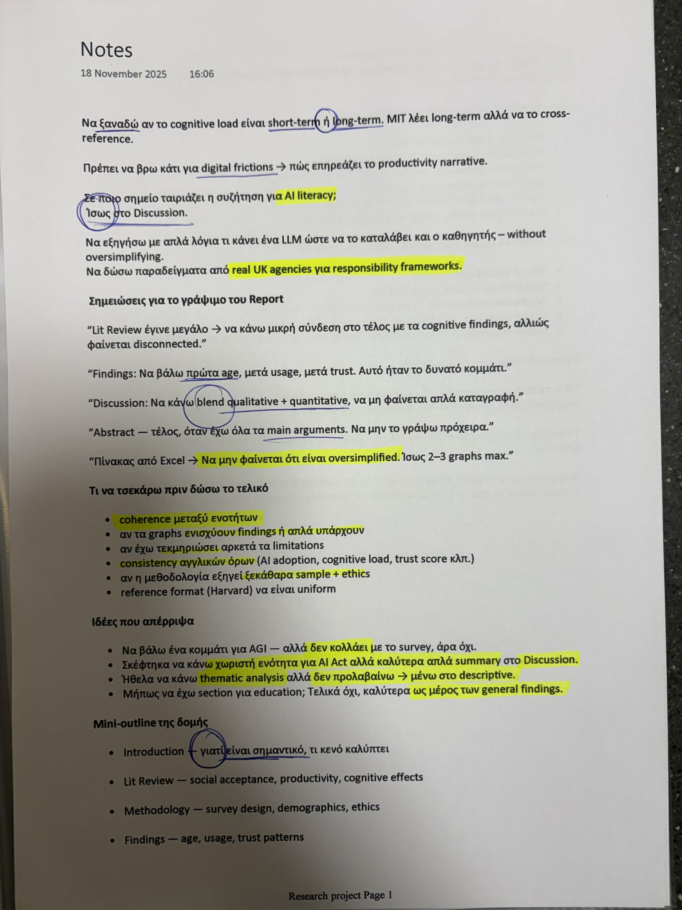
Figure 29: General notes
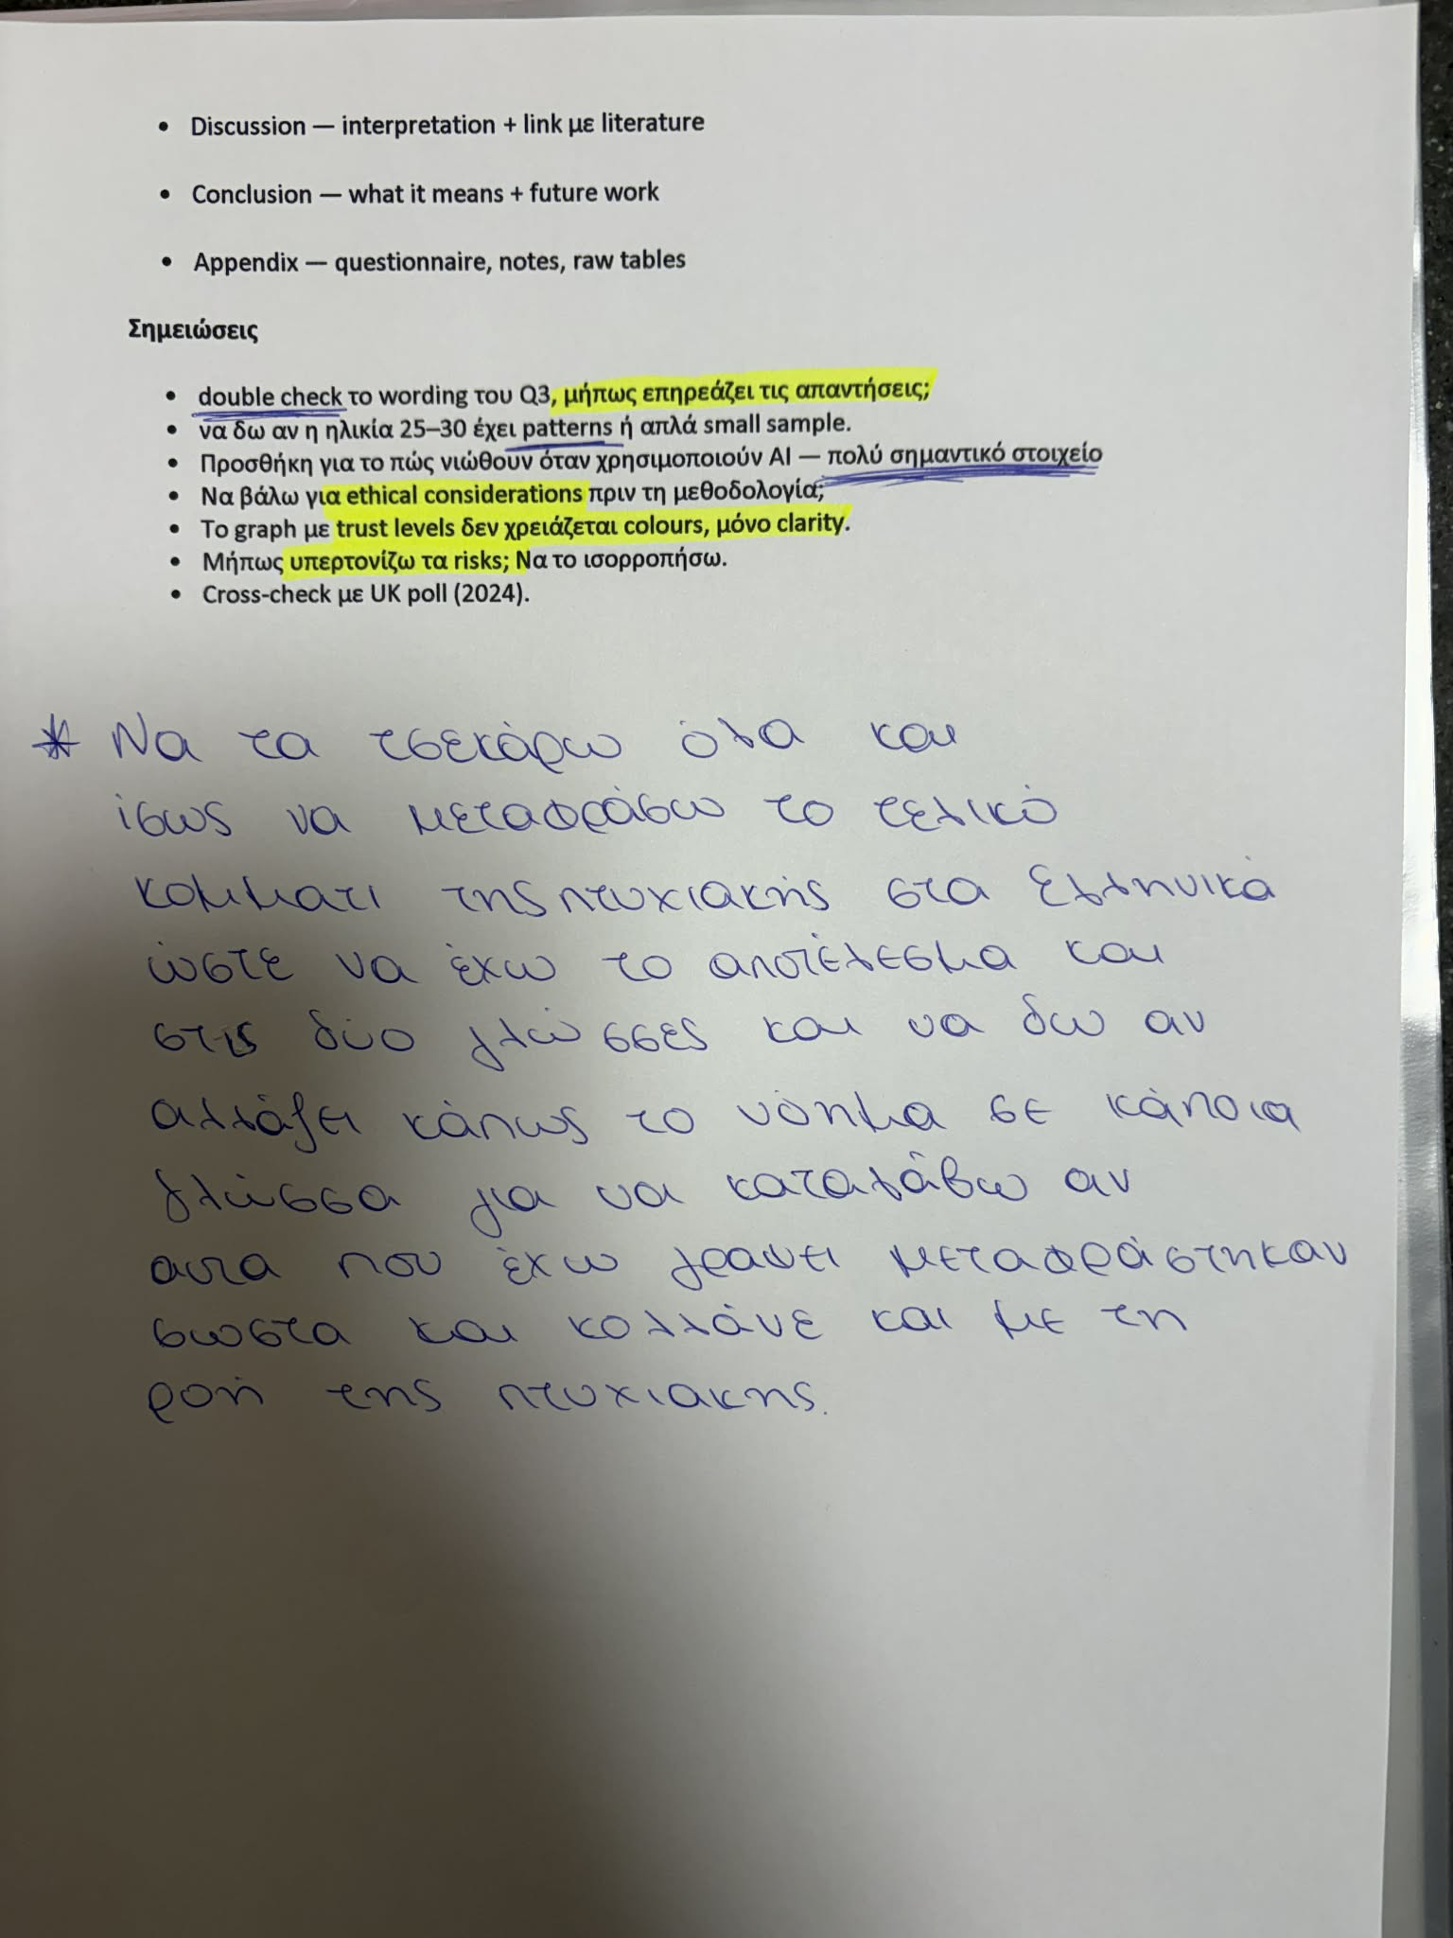
Figure 30: General notes
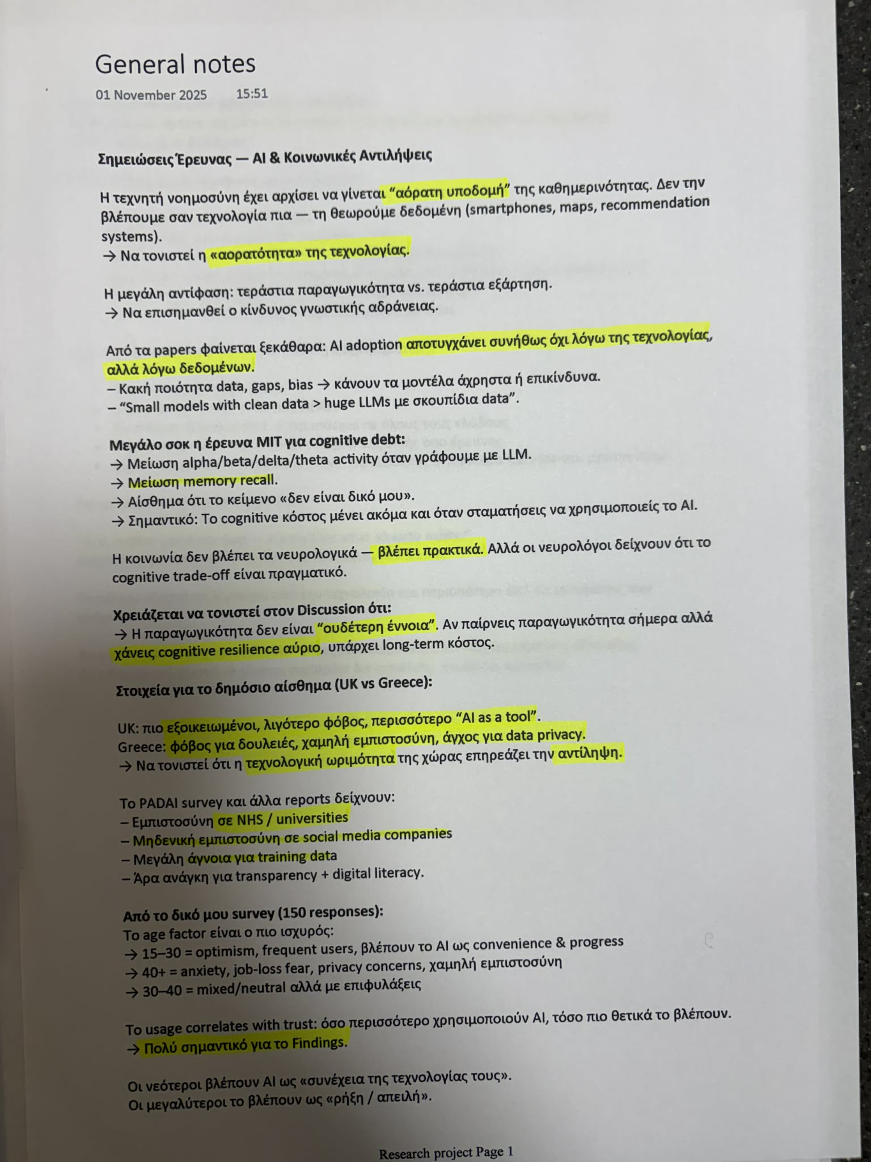
Figure 31: Notes in Greek.
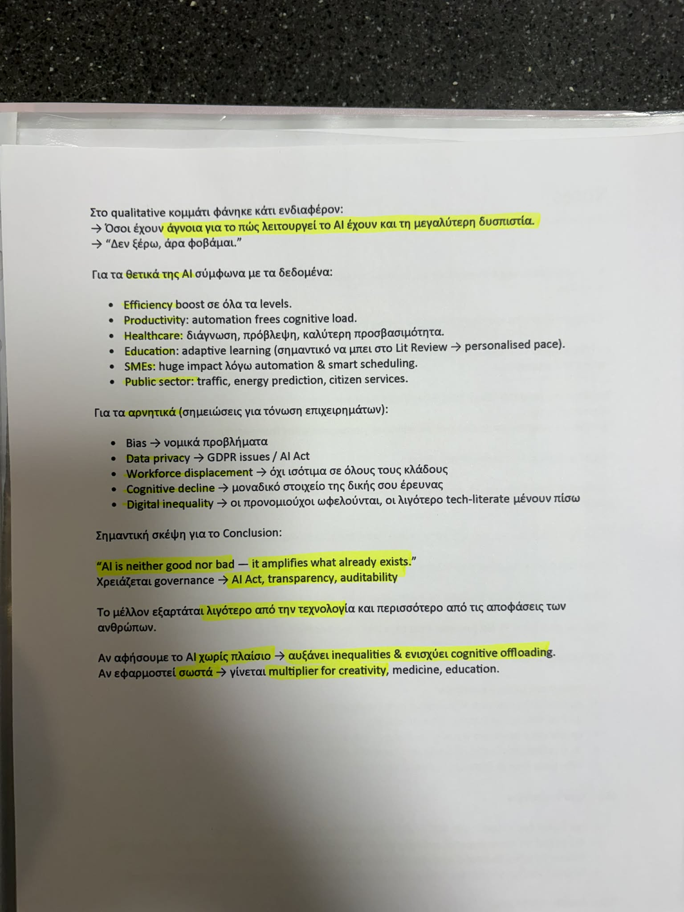
Figure 32: Notes in Greek.
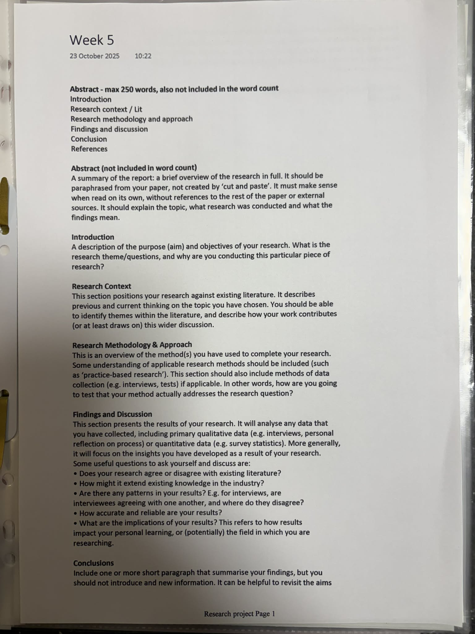
Figure 33: Class notes
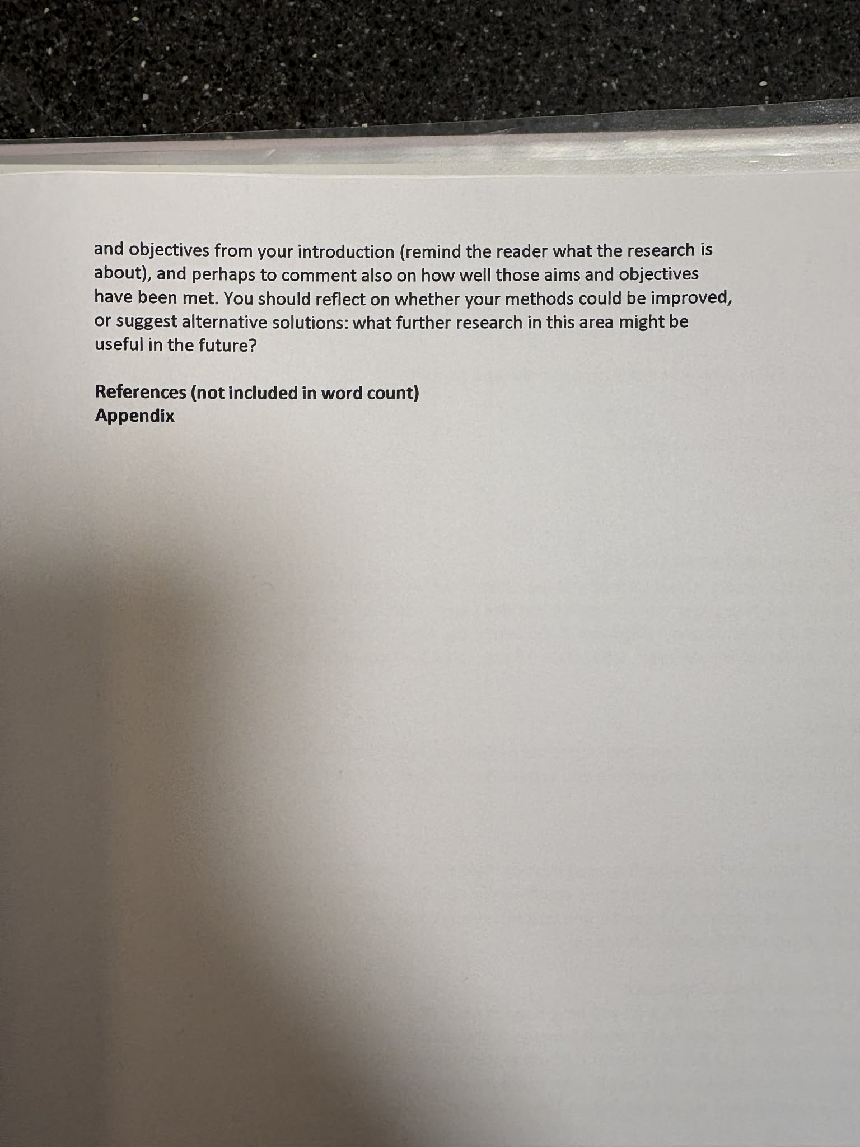
Figure 34: Class notes

